## **Hands-On Activity: Adding your portfolio to Kaggle**

**TOTAL POINTS 1**

1.

Question 1



As you create your data analytics portfolio, you might find yourself using Kaggle or another online platform to host it. Kaggle hosts interactive notebooks that let you showcase your hard work. If you have R code in your portfolio, this is a great option! In this hands-on activity, you’ll learn how to move your portfolio’s R code to a Kaggle notebook and publicize it.

### Types of notebooks



First, it’s helpful to know the different kinds of notebooks on Kaggle. Every kind of notebook utilizes code, but each one contains different languages for programming or writing text.

* Scripts: Cells can be formatted in R or Python only. They execute each cell as code sequentially.
* RMarkdown scripts: Cells can be formatted in R and RMarkdown only. These files are preferred by many R authors.
* Jupyter Notebooks: Cells can be formatted in Markdown, R, or Python. These are most suited to flexibility.

Before you create a notebook in Kaggle, you should know which kind of notebook you intend to use. Will you use any Markdown or RMarkdown to add context to your work? Will you be using R or Python? The answer to these questions will determine which notebook you use.

### Adding R to your notebook



Step 1: To begin, go to [Kaggle.com/code](https://www.kaggle.com/code) and click + New Notebook to create a new notebook. If you want to use an existing notebook, go to the Your work tab and scroll to the notebook you want to use.

Step 2: Once you have created your notebook, decide whether you want to use a type of script or a Jupyter notebook, based on your project’s needs. The editor will begin on default as a notebook. If you want to change your notebook to a script, click on File at the top of your editor and hover over Editor Type. This opens a drop-down menu to select Notebook or Script. Select the format you want to use.

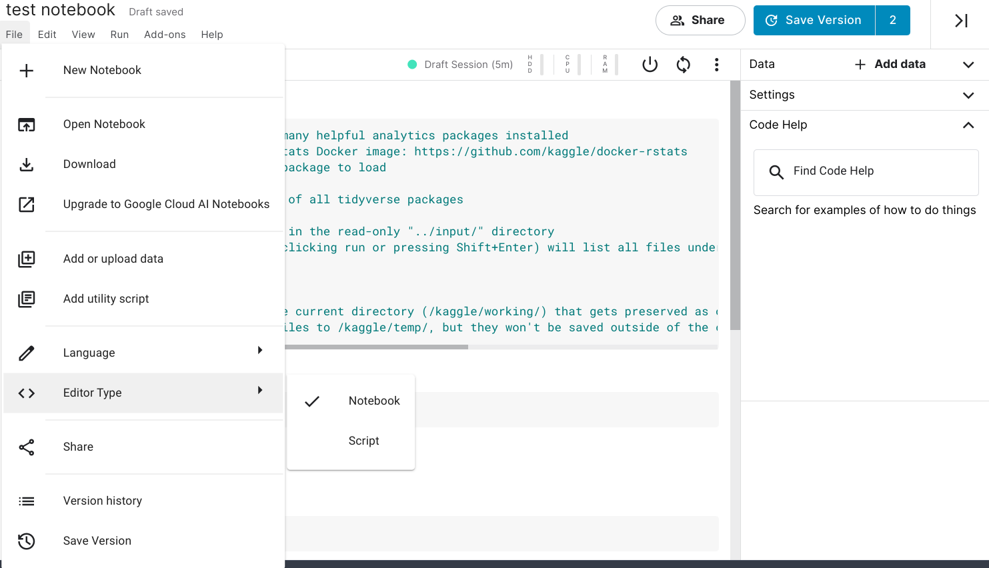

Step 3: Since we want to work with R instead of Python, it’s time to change the notebook’s language. Click on File at the top of your editor and hover over Language. This opens Select R if it isn’t selected already.

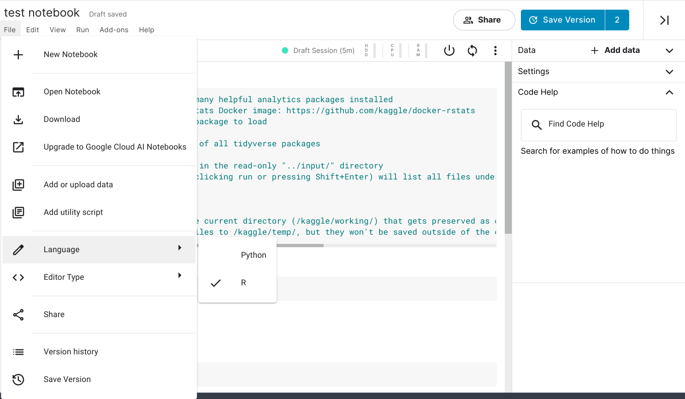

Step 4: Add the content of your portfolio piece. Add a new cell to the document by clicking + Code or + Markdown. It helps to click run your code as you write it or paste it in to ensure that it doesn’t return an error.

Step 5: Repeat these steps until you have created or uploaded your portfolio pieces to Kaggle.

You have now created your portfolio in Kaggle! Your next step is to publish your work and share your portfolio.

### Publishing your portfolio



Now, it’s time to publicly publish your portfolio on Kaggle. This will allow peers, hiring managers, and potential employers to view your hard work and skill set.

Step 1: To begin, either navigate to the Your work tab on the Code screen or enter the url, kaggle.com/[your profile name]/notebooks into your address bar to bring you to the list of your notebooks and scripts.

Step 2: Click on the first notebook or script you’d like to publicize. At the top right-hand corner, click the Share button with the lock icon.

Step 3: If the pop-up window states that the document is private, click on the word Private. This will open a drop-down menu where you will be able to select Public. On this window, you’ll be able to add any relevant tags or collaborators who contributed to the document.

Step 4: Repeat these steps until you’ve made each piece in your portfolio public on Kaggle.

Congratulations! You have uploaded your portfolio to Kaggle and can now share your hard work with friends, family, colleagues, hiring managers, and potential employers. You can update your portfolio as your skills as a data analyst continue to grow.

Now, you can share your portfolio by going to the Your work tab on Kaggle and copying the link from the address bar. You can also type “kaggle.com/[your profile name]/notebooks” into your address bar to access the correct page. Share this link to show the world your hard work!

## Did you complete this activity?

**1 / 1 point**

Yes

No

**Correct**

Thank you for completing this activity! A public portfolio helps you showcase your work to your peers, hiring managers, and potential employers. It is crucial to develop your online presence as part of your career development. Using Kaggle, you can easily post, edit, and share your work with whoever you want to see it.